## ASSIGNMENT 1 –

### SECTION A

1. List all system databases in SQL Server

SHOW Databases;

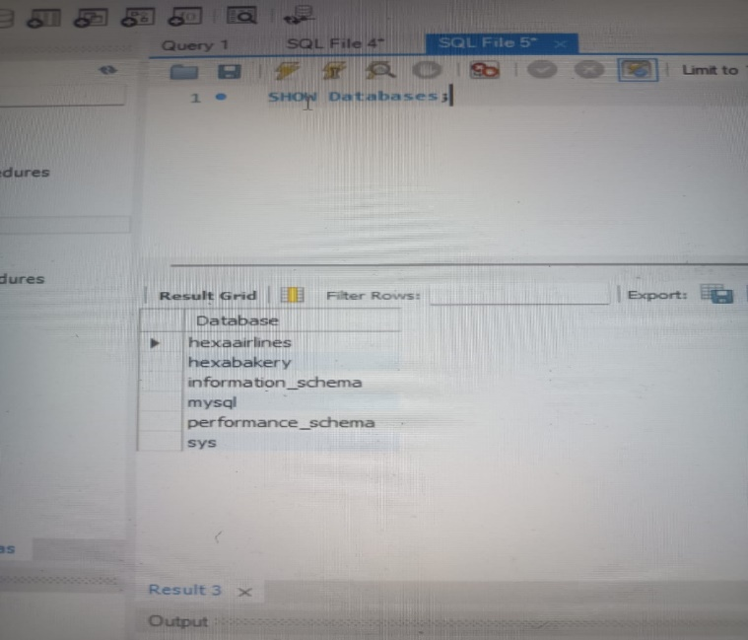

1. List physical file paths for all databases

SHOW VARIABLES LIKE 'datadir';

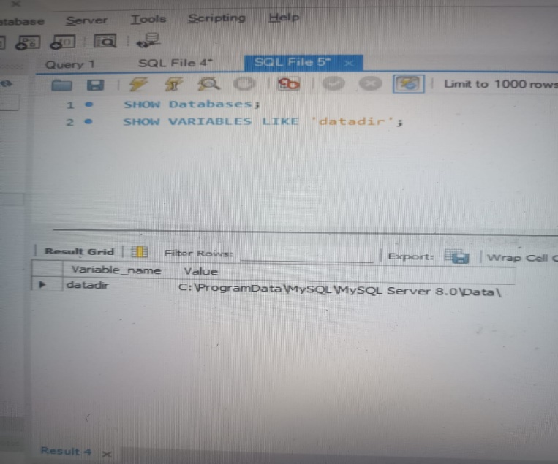

1. Create a new user-defined database named TeamDB

CREATE DATABASE TeamDB;

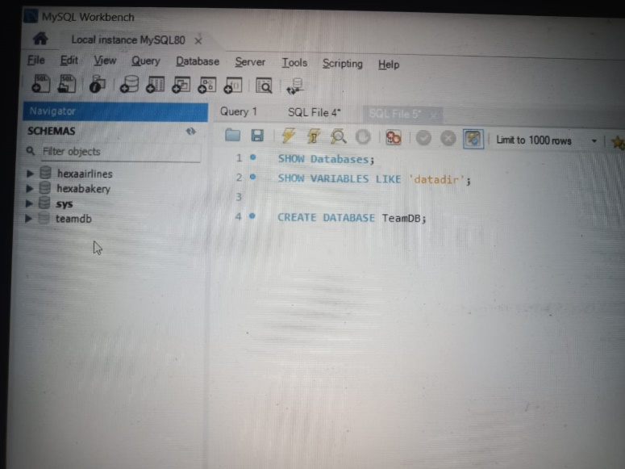

1. Rename the database TeamDB to ProjectDB.

CREATE database ProjectDB;

DROP Database teamdb;

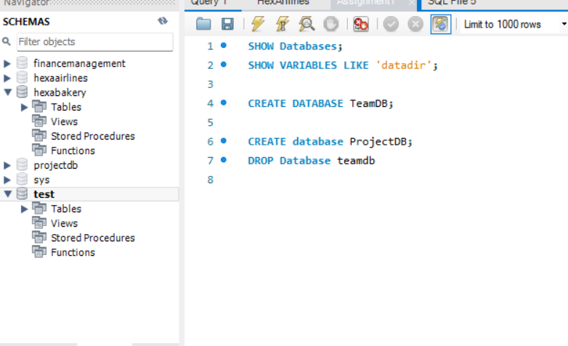

1. Drop the ProjectDB database

DROP DATABASE PROJECTDB;

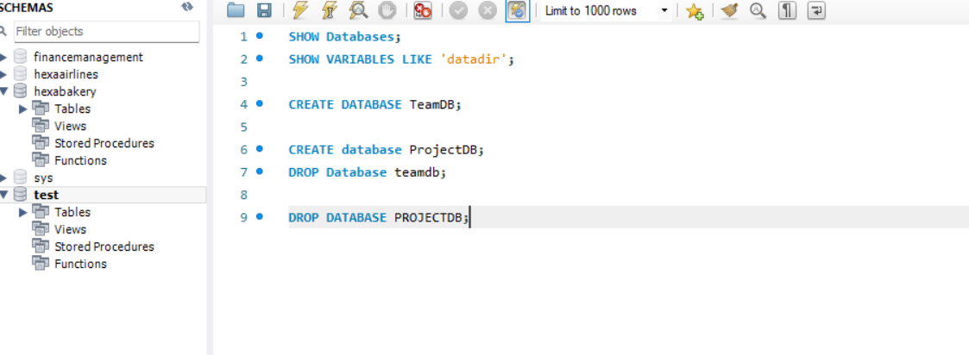

### MANAGING TABLES (SECTION B)

1. Create a table Employees with the following columns

CREATE DATABASE ASSIGNMENT1;

USE ASSIGNMENT1;

CREATE TABLE Employees (

EmpID INT PRIMARY KEY,

Name VARCHAR(50),

Department VARCHAR(30),

JoiningDate DATE,

IsActive BOOLEAN,

Salary DECIMAL(10,2)

);

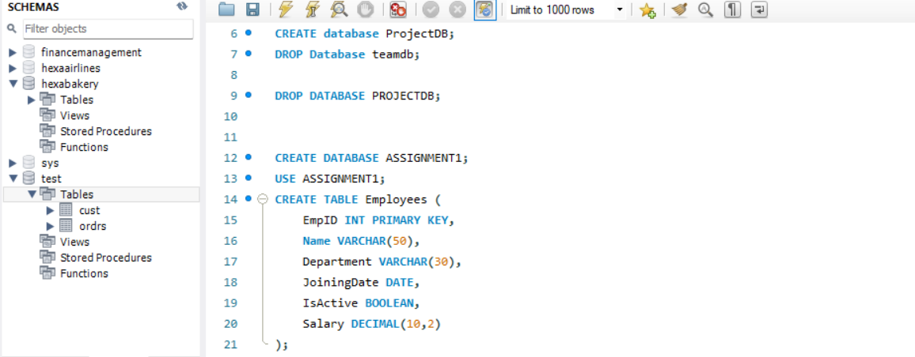

1. Add a column Salary (DECIMAL) to the table.

ALTER TABLE Employees ADD COLUMN Salary DECIMAL(10,2);



1. Rename table Employees to TeamMembers.

RENAME TABLE Employees TO TeamMembers;

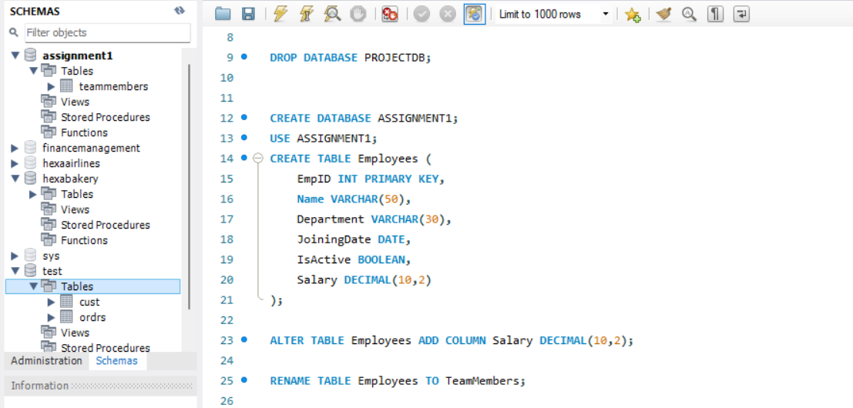

1. Drop the table TeamMembers

DROP TABLE TeamMembers;



### DML OPERATIONS (SECTIONS C)

1. Insert three rows into Employees.

CREATE TABLE Employees (

EmpID INT PRIMARY KEY,

Name VARCHAR(50),

Department VARCHAR(30),

JoiningDate DATE,

IsActive BOOLEAN,

Salary DECIMAL(10,2)

);

INSERT INTO Employees (EmpID, Name, Department, JoiningDate, IsActive, Salary) VALUES

(1, 'Amit', 'HR', '2022-01-01', TRUE, 50000),

(2, 'Sneha', 'IT', '2021-06-15', TRUE, 75000),

(3, 'John', 'Finance', '2020-10-10', FALSE, 65000);

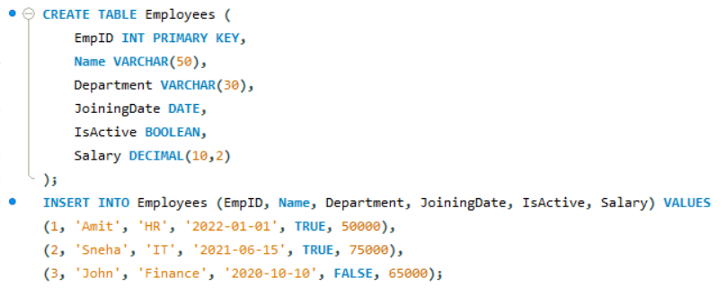

1. Update salary of 'Sneha' to 80000

UPDATE Employees SET Salary = 80000 WHERE EmpID = 2;

SELECT * FROM EMPLOYEES;

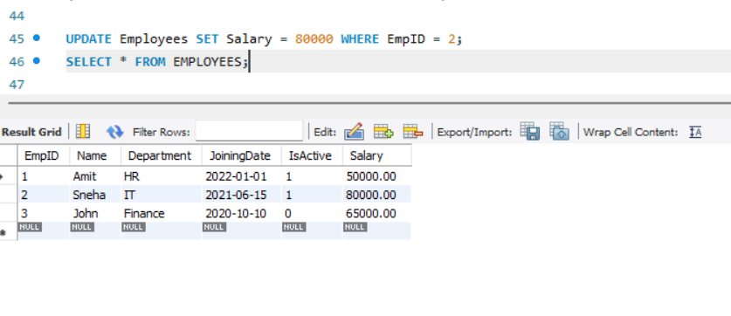

1. Delete employee with IsActive = 0

DELETE FROM Employees WHERE IsActive = FALSE;

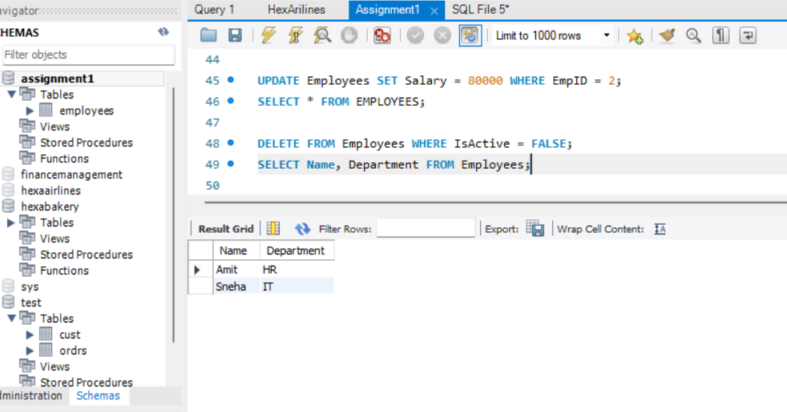

1. Retrieve the name and department of all employee’s

SELECT Name, Department FROM Employees;



1. Fetch employees from 'IT' department with salary above 70000

SELECT * FROM Employees WHERE Department = 'IT' AND Salary > 70000;

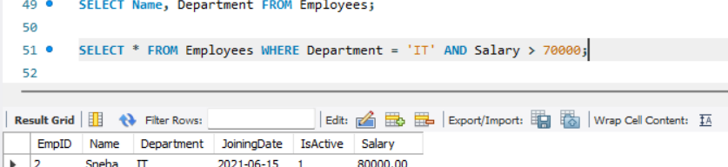

1. Apply filtering using LIKE, BETWEEN, and IN.

SELECT * FROM Employees WHERE Name LIKE 'S%';

SELECT * FROM Employees WHERE Salary BETWEEN 60000 AND 80000;

SELECT * FROM Employees WHERE Department IN ('IT', 'Finance');

